Static Routing -configration
In this lab, three routers were connected, each with a different network. Static routing was configured between the routers to allow communication among all network and connectivity was successfully verified using the ping command.
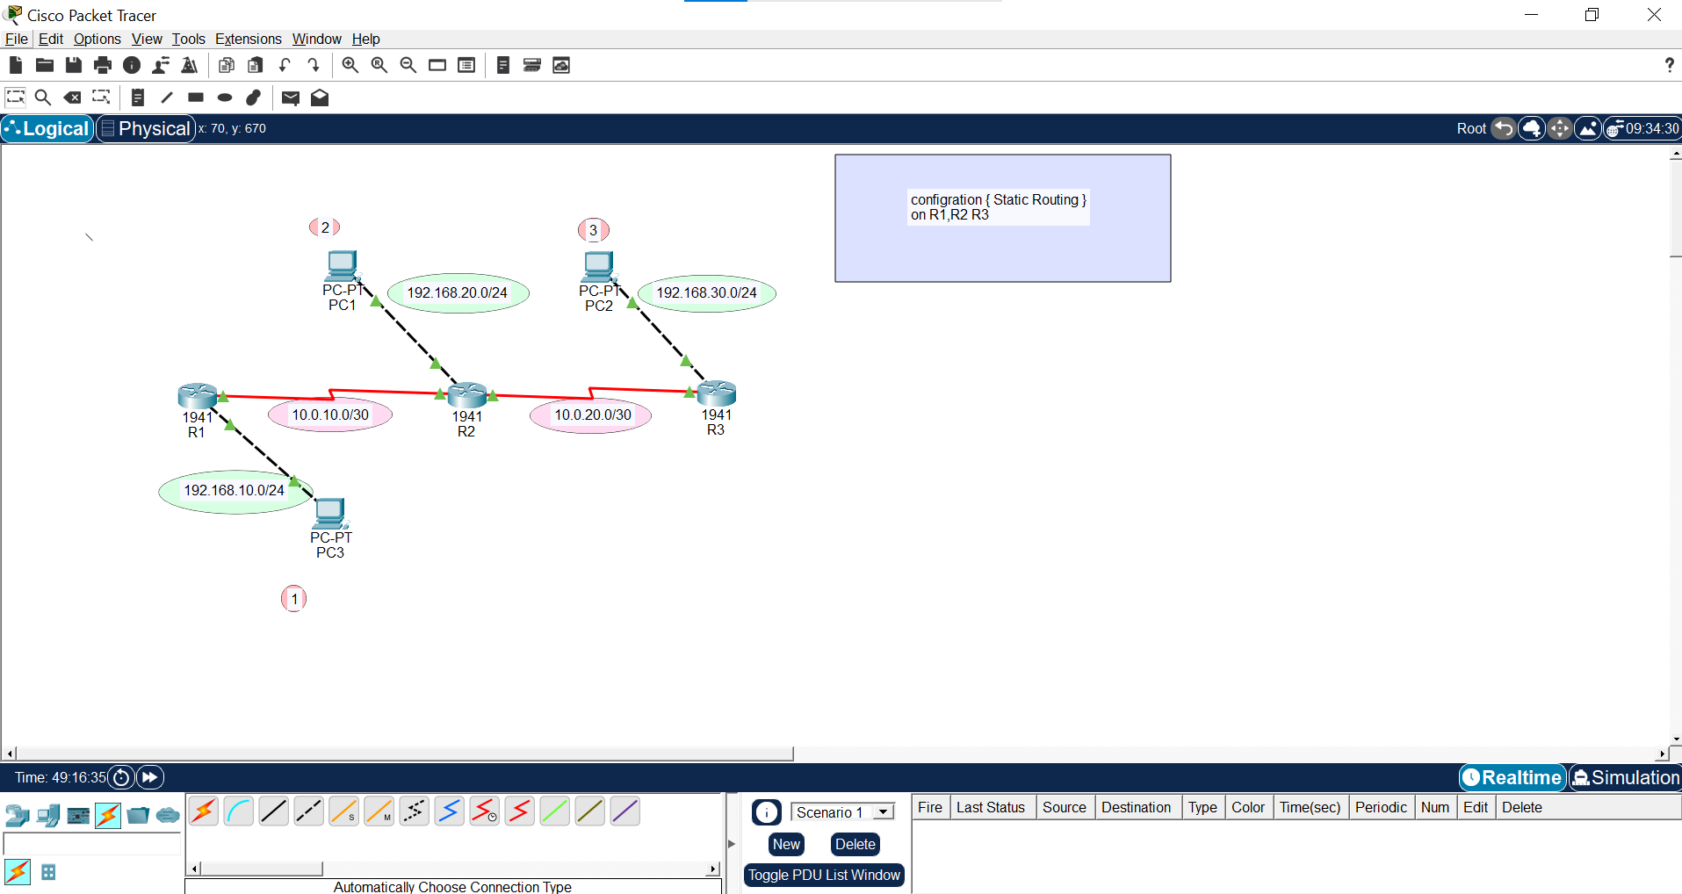


R1-router1
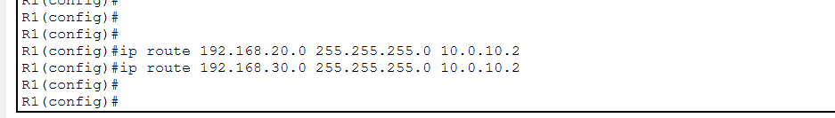

R2-router2
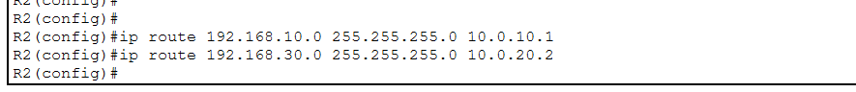

R3-router3
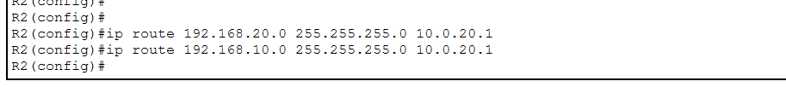


R1-router1 -routing table
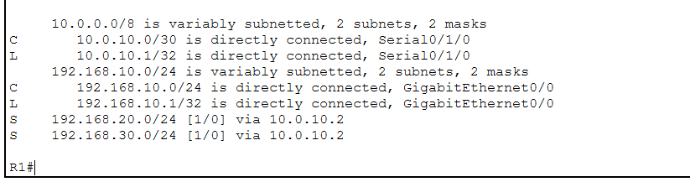

R2-router2-routing table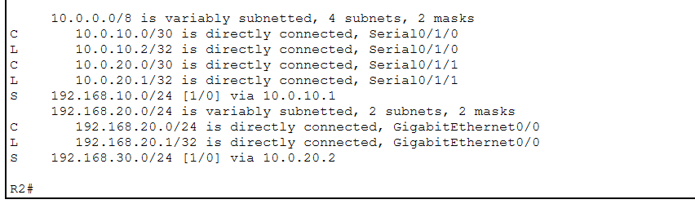

R3-router3- routing table
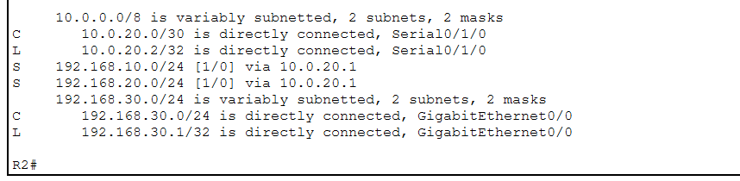


Pc with ping to another network
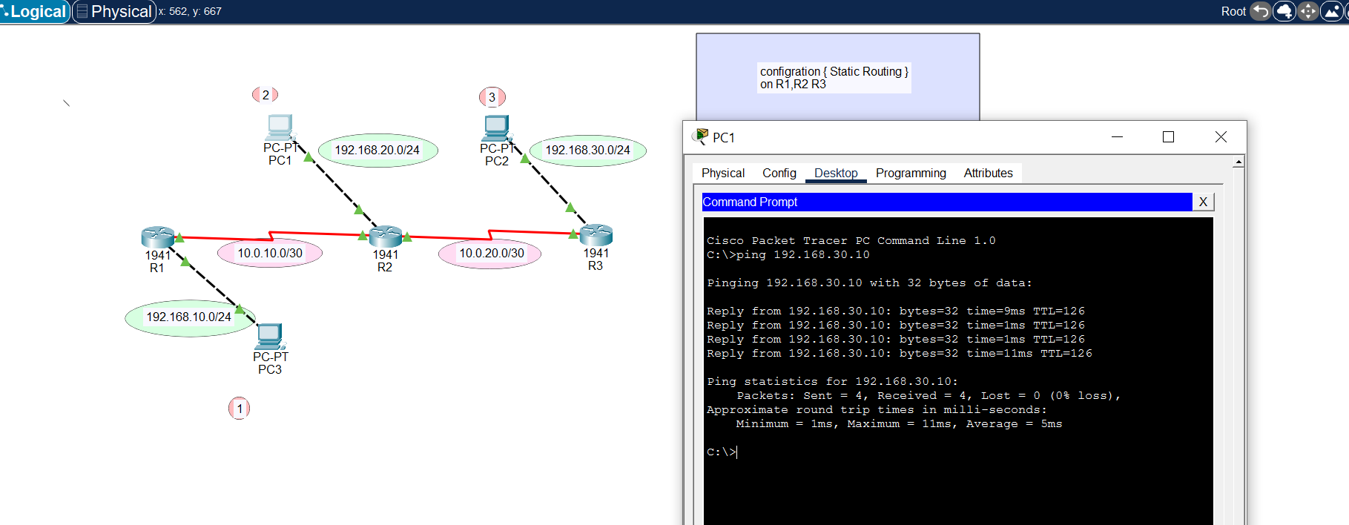

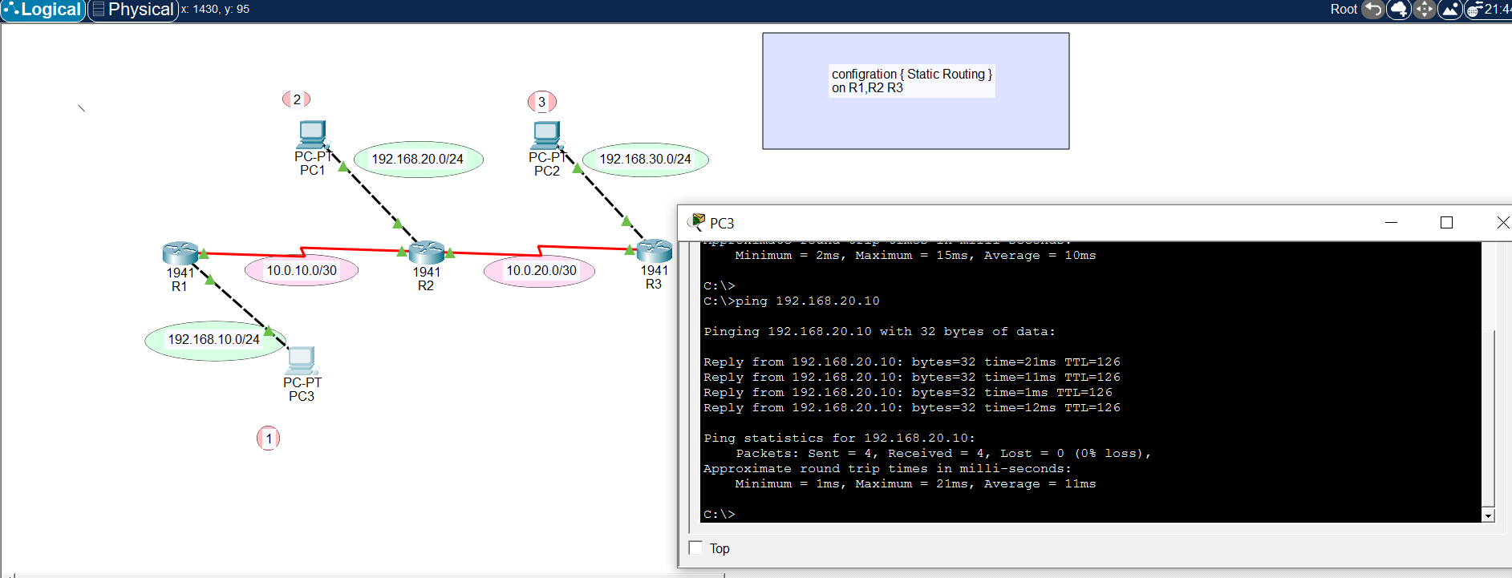

Sara abu zyoud

